>
Teknisk uddybning af generelle egenskaber for Sag og Dokument  Denne vejledning kan frit anvendes af alle. Citeres der fra vejledningen i andre publikationer til offentligheden, skal der angives korrekt kildehenvisning.  Vejledningen er udarbejdet af OIO-udvalget for tværgående sags- og dokumenthåndtering.  Kontaktperson for OIO-udvalget:  Projektleder Carsten Rohde  Mailadresse: carr@itst.dk  Direkte telefon: +45 3337 9273 |  | Udgivet af:  IT- & Telestyrelsen  IT- & Telestyrelsen  Holsteinsgade 63  2100 København Ø  Telefon: +45 3545 0000  Fax: +45 3545 0010  Publikationen kan hentes  på IT- & Telestyrelsens  Hjemmeside: http://www.itst.dk  ISBN (internet): [Angiv]  ISBN: [Angiv]

Technical deepening of general characteristics for Case and Document

The Reference Committee for file and document area
XX.XX 2010
>
Contents >
1. Introduction 5
1.1 Reading guide 5
1.1.1 Audience 5
1.1.2 Notation 5
2 From the business object to the Service Interface 6
2.1 Objectet’s ”Anatomy” 6
2.1.1 Object ID 8
2.1.2 ObjectRegistration 8
2.1.3 Attributes 9
2.1.4 Relations 9
2.1.5 States 10
2.1.6 UML Diagramming 11
Example Objects - Document 13
Registrering 13
Attributter 15
Relationer 16
Tilstande 17
Total virkning 19
2.2 Timing Change - Temporal Properties 20
2.2.1 System time 20
2.2.2 Registration 21
2.2.3 Effect 22
2.2.4 Example 24
3 Service Operationer 25
3.1 Løsningsarkitektur 25
3.2 Input 25
3.3 Output 26
3.3.1 Fejlhåndtering 26
3.3.2 Transportprotokol 26
3.4 Data Service API 26
3.4.1 Opret 26
3.4.2 Læs 28
3.4.3 Opdatér 28
3.4.4 Slet 29
3.4.5 Import 30
3.4.6 Passiv 30
3.4.7 List 31
3.4.8 Søg 31
Hændelser 32
Baggrund 32
Hvad er en hændelse? 32
Operation API for Hændelser 33
Hændelsesfordeler 33
HændelsesModtager 34
4 Referencer 35

Reading guide

1. Introduction
This document relates to file and document area's specifications published for consultation 12th October 2009. Specifically, the following is a technical elaboration of the "General characteristics of service interfaces at the case and document the area" and contains a more detailed review of the general characteristics of the various service interfaces. This is the document that the consultation letter in connection with the specifications cited as further evidence of the general characteristics.
This document describes the objects, conditions and relationships, but is mainly active in detail with the temporal properties (recording and effects), and the specifications related operations.
It should further be noted that IT and Telecom Agency has launched a POC (Proof of Concept) to illustrate the logic specifications can be implemented in systems. This document is inspired by the first POC in the area who have used the specification "Specification of service interface for the document" as a basis, why service interface document used as an example in large parts of the material.

Audience
The target audience for this document is primarily architects with software suppliers who must implement these interfaces. In the second series of architects in the public sector who are considering buying interfaces as described in the specifications.

Notation
- UML - A UML 2.0 notation used in diagrams and domain models.
- Pseudo code - used pseudo code in the examples
- Use XML fragments in some of the examples
- Code / Pseudo Code is written in NewCourier font.

From the business object to the Service Interface
Reference Architecture² (Reference Architecture for case and document field (EDM), 2008 ") has defined a number of business objects, and include them subsequently translated into specifications for service interfaces in the areas:

- Case
- Document
- File structure
- Organization
- Classifikation

The specifications have the following implicit assumptions:

- They specify the information an object contains and how operations affect the
- A service interface is represented as a service endpoint with the methods (operations).
- Service interface logical structure is returned after a service call.

The description of objects in the following additional documentation regarding the service interfaces based on that there are some common general properties of objects.

Objectet’s ”Anatomy”
To define an extended generalized model for all objects in those specifications, as shown in Figure 1 below. The model provides an overview of the objects, attributes, states and relationships and temporal properties (see later on efficacy and registration as discussed in more detail in the section on "Time-based changes - temporal properties).
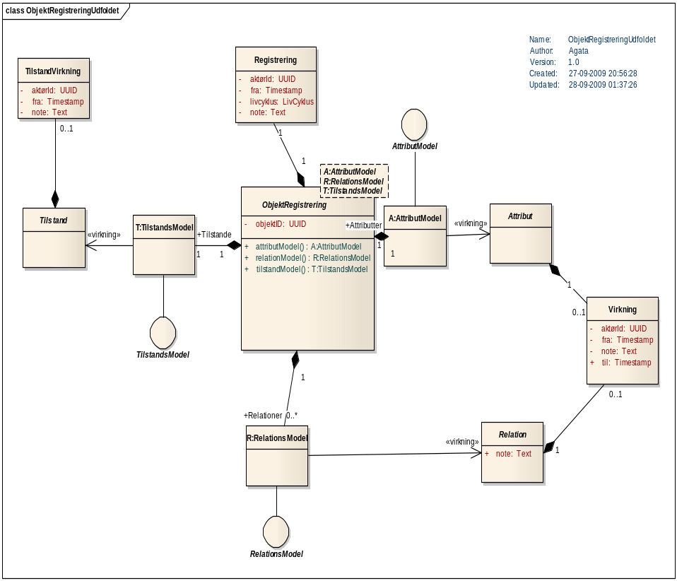
Figure 1 Object registration - with stereotypes

All concepts in the above chart is explained in the following table:
Chart | Explanation
ObjektRegistrering | Object registration is a super type, which represents the state of a resource after the call to a service operation.  Object recognition is modeled as a template type that is dependent on a AttributModel, a relational model and a state model.  Specifically, this means that subtypes, such document shall become bound to the super type, they define their own models.
Registrering | An object recognition has assigned a unique registration representing transaction time of service operation.
Virkning | Effects are used to equip parts of the object (Attributes, Relationships, States) with properties relating. perspective.
TilstandVirkning | A state may also have an effect but it must not have an "expiration" period.
AttributModel | At a general level AttributModellen abstract. It is implemented for each Service Interface and describes the attributes of service has.
RelationsModel | At the general level of relationship-model abstract. It is implemented for each Service Interface and describes the relations service has. Of the relationships in an object called the Relational Model
TilstandsModel | At a general level state model abstract. It is implemented for each Service Interface, and describes what conditions service has.
Attribut | Represents a data structure which is a sub-element of the object. Attributes can be associated with Impact.
Relation | Represents a reference to a resource (foreign business object) to be accessed via a service. Relationships can be assigned Effect.
Tilstand | Condition specifies a semantic attribute of the object. We operate with little state characters per second. object, each with defined specific values.

Object ID
The object is assigned a globally unique objektID of type UUID when it is created. Although the object state changes and content over time, its UUID is not changed - it's part of the service's business logic. UUID used to link data together across services and across the Records and Effects.

ObjectRegistration
An object in this context is actually an instance of an object as it appears at any given time of recording - it refers to as the body registration or Object (Ix, rx).

In this way, every object represented by one or more object records. An instance of an object retains its Object Type and objektID in different records.
O(i1,t1), O(i1,t2), O(i1,t3) ...

An object recognition is immutable, i.e, it cannot be changed. Instead, the service form new instances of ObjektRegistering, with new file recording, updated values and possibly with a changed lifecycle.
En ny ObjektRegistreringsinstans bliver skabt efter hvert af følgende operationskald:
- Opret
- Ret
- Slet
- Importer (?)
- Passiver (?)
There can only be edited and deleted in light of the recent registration of the instance. However, you can list and / or search all records of objektinstansen. (See also section on "Service Operations"for further description of the operations associated with the service interface).

Attributes
An attribute is an element that has an impact period. This allows content of the attributes change over time. Objects may contain attributes. For example, document a class attribute, called the document properties:

DokumentEgenskaber
Titel:Text
AndenTitel:Text
...

Relations
A relation expresses a reference to a resource in another service, called foreign object. Relationship effect period. This allows the relation content changes over time.
Of the relationships in an object called the Relational Model.
As an example a subset of relational model for the document in Figure 2, and it appears that:
- Document has a relation to a number of resources in the service document (itself or another), and the relationship is called "Annex”.
- There are still a relation of cardinality first. n to the service document, titled "Another document”.
- There is a relationship with cardinality 1 to the service called Document Assumptions.
- Document has a relation to a number of resources in service Archive.
- The figure also shows that the document has a single relationship with actor and a plural relation to Actor.

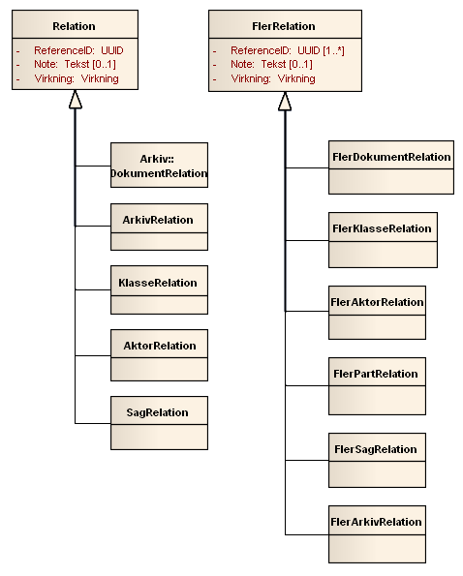
Figur 2 Relational Model, shown here for some of the relationships defined in Document.

States
States are defined with fixed outcomes, as state is an attribute that can describe anything about the object on a time axis. It may, for example. describe momentum, publishing, and similar quality.
States may also have an effect, but this works a little differently than the general effect. A state action has a "from" time, but nothing "to". This allows a state only replaced by another state..

UML Diagramming

Temporal pattern and stereotype <<virkning>>
We have chosen to use repetitive (repetetive?) patterns to illustrate how temporal effect linked to model elements. To end with straightforward diagrams, it was decided to use stereotypes to present the temporal pattern of effect.

We use stereotypes to present changes over time:
- Impacts on Modes
- Effects on Attributes
- Effect on Relationship
- Special adaptations specific to the individual Service Interface.
We represent the stereotype <<virkning>> over a UML association to indicate that in reality is a collection of elements, each with their effect.
We say that we filter object in terms of an effective range when selecting a subset which corresponds to a specific effect period.
This pattern and notation follow Martin Fowler's Temporal Pattern, see [Fowler].
Below is an example of a subset of UML diagram for the document in which the stereotype <<Virkning>> is used in target-role the endpoint of the association of document relationship model. In reality, there is a collection of links of type File, each with their effect. But when the effects can not overlap, is that each time exactly (only?) single file relation, valid.

Collection<Arkiv>
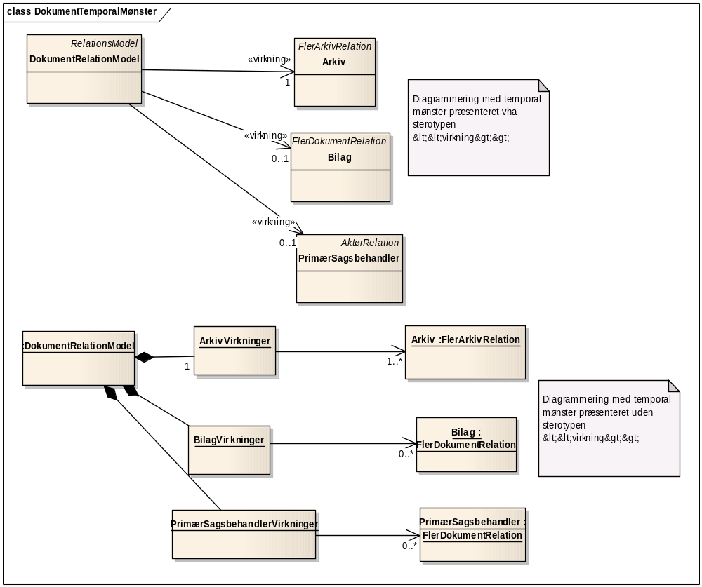
Figur 1
Illustration 1: Temporal mønster vises i UML diagrammer med stereotypen <<virkning>>

Figur 3: Temporal pattern appears in the UML diagram with stereotype <<virkning>>

Template classes and <<binding>>
We use a parameterized class (aka template types) to define a general structure as a template.
Its functionality can be implemented by tying one type for the parameterized class - and when it binds to specify the types that are tied to the parameters. A classic place where parameterized classes are used in Collection Library in Java / C #..
Object recognition is a parameterized class, with the following parameters:
- A is a parameter of type AttributModel
- R is a parameter of type relation model
- T is a parameter of type condition model
Instead of a class specializing a template class, it can be stated that the class bound to the Template class.
- This is done by using a dependency association with <<bind>> stereotype.
For example below shows that the Document is tied to the object model with the following parameters:
- • DokumentAttributModel instead of A
- • document related model instead of R
- • Document state model instead of T.

Example Objects - Document
As described in the previous chapter is accompanied by a number of general properties for each object. In this chapter, a concrete example of an information model - the model for the document - will be reviewed in order to describe how the specific model relates to the general characteristics.

Registrering

The figure below shows a detail of the information model document. Object Document contains, in accordance with the description of the general characteristics of an ID of type UUID. Additionally, document a user-facing key. The purpose of the user-facing key is to have an unchangeable identification of the document, as opposed to the document ID can be presented to the user.
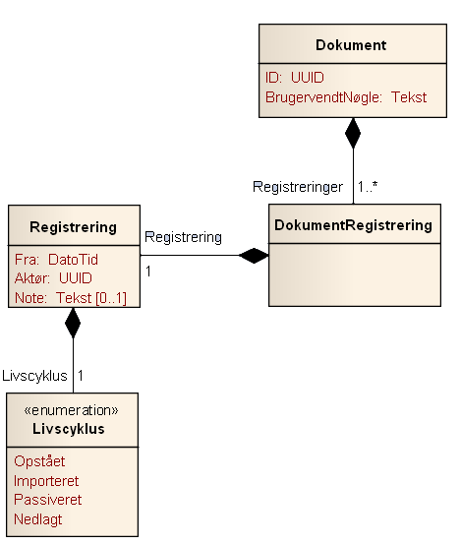
Figur 2

A document containing a number of records called the document registration. Creating a new document registration, each time performed an operation that modifies the document attributes, conditions, or relationships. Element Registering a specific date and time of registration, a reference to the actor who has made the registration, and document lifecycle. Finally, it is possible to attach a note to the registration.

Attributter

For every object is assigned a number of attributes. In the information model document placed these attributes in an element called DokumentAttributListe. For a given document recording falls just one DokumentAttributListe. For Document, there is just one type of attribute: the attribute Properties, which is of type document properties. The actual type of document properties consist of a number of fields which are described in the standard for document. In this context, two facts are worth noting:
First, it represents the Title field in the Properties attribute of the document Object Name. Title is the actual name for generic title Object Name.
Second, the document properties associated effect. This means that the document properties may change over time. For a concrete document registration can however see which properties that have been effective at what times.
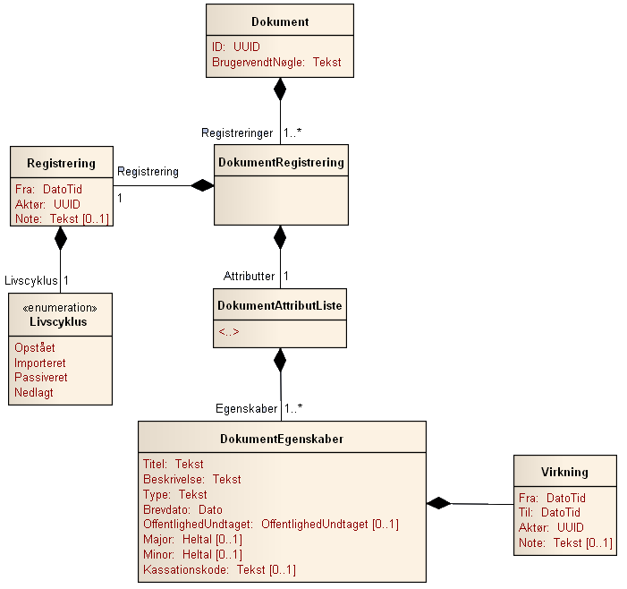
Figur 3

The symbol <..> in the element DokumentAttributListe in Figure 6 indicates that allowed for a concrete application of the information model document to add additional attributes. However, it is a requirement that these attributes must have effect. Figure 7 indicates an example of a concrete application, which is added an additional attribute - English translation:
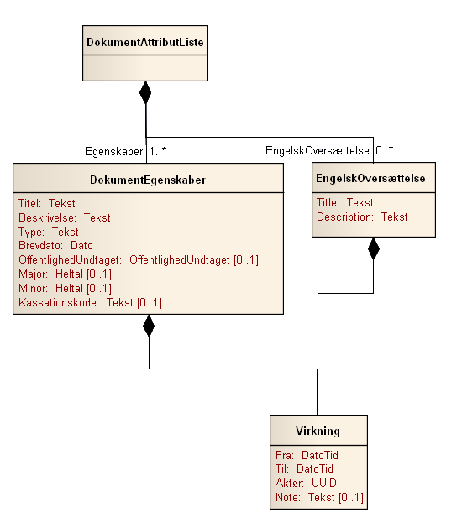
Figur 4

Relationer

For every object is assigned a number of relationships. In the information model document placed these relations in an element called the document related list. For a given document registration is attached just a document related list.
The symbol <..> in the element related document list in Figure 8 indicates that permitted for a specific use of the information model document to add further links. However, it is a requirement that these relations must be either of Relationship type or type multi-relation. Figure 10 indicates an example of a concrete application where there is an added relationship - Document Type:

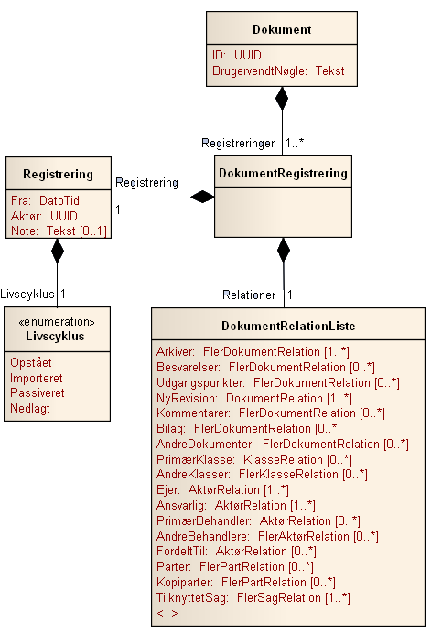
Figur 5

All relations inherit either from the general element Relations, which represents a reference to one other object of a particular type or from the general multi-component relationship, which represent references to a number of objects of a particular type. Figure 9 indicates the model for Relational and multiple relationship. Note that both Relational as multi-link takes effect.
The actual reference is represented in the model by using a UUID.

Tilstande

For every object is assigned a number of states. In the information model document placed these attributes in an element called the document status list. For a given document recording falls just one document state list. For Document, there is precisely one state, namely state Propulsion, which is of type document progress. The actual document type propulsion consists of two fields, namely the Status field that indicates the state's status as well as field effect, which indicates that the condition has effect. It is thus possible from each document state list to see what the document Progress has been at different times. Note that the impact of modes, mode effect, differs from the general effect of not having a To field. This is due to the conditions in contrast to attributes and relationships can not be "holes" in the registration. One document must always have a propulsion. To field would be redundant and are therefore not included in the information model.

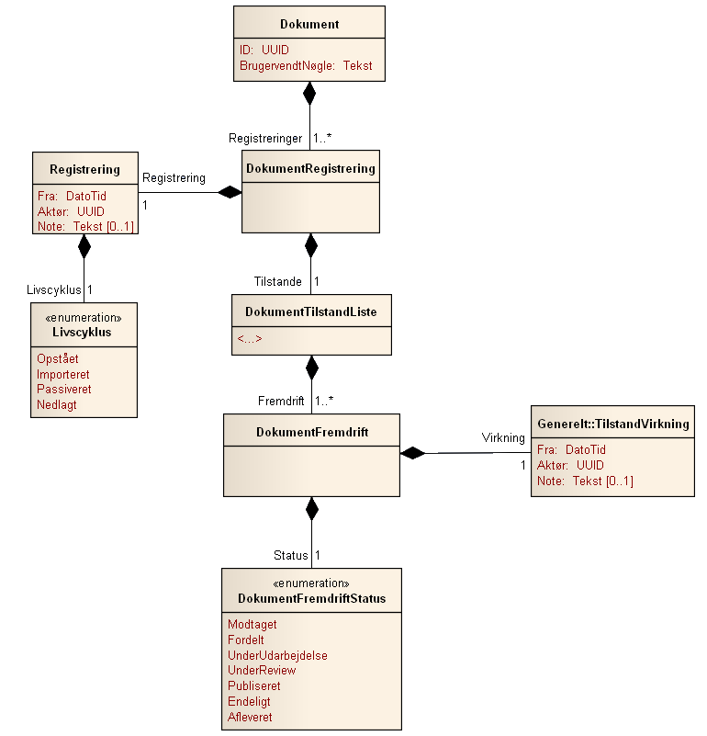
Figur 6

The symbol <..> in the element document status list in Figure 11 indicates that it is permissible for a concrete application of the information model document to add additional states. However, it is a requirement that these relationships must have status (which is a enumereret list) and effect (type mode effect). Figure 12 (10?) indicates an example of a concrete application where there is an added condition - Approval:
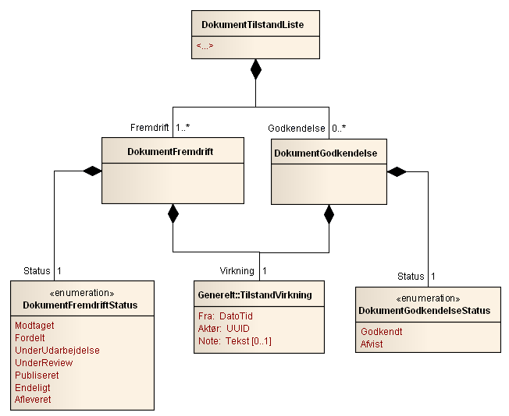
Figur 7

Total virkning

Figure 13 (11)? shows the overall information model for the document. As the chart shows, in addition to the already described elements added an extra effect on document relationship. This effect indicates the total effect of the document. Document has a number of mandatory elements: Properties is an example of such a mandatory feature, Owner is another. Although these elements are mandatory, there may be gaps in their effect. However, there may be only a hole in a compulsory element effect, if the document at the time had no effect. The document indicates the total effect is, the periods in which at least one of the document elements (including all mandatory elements) had effect.
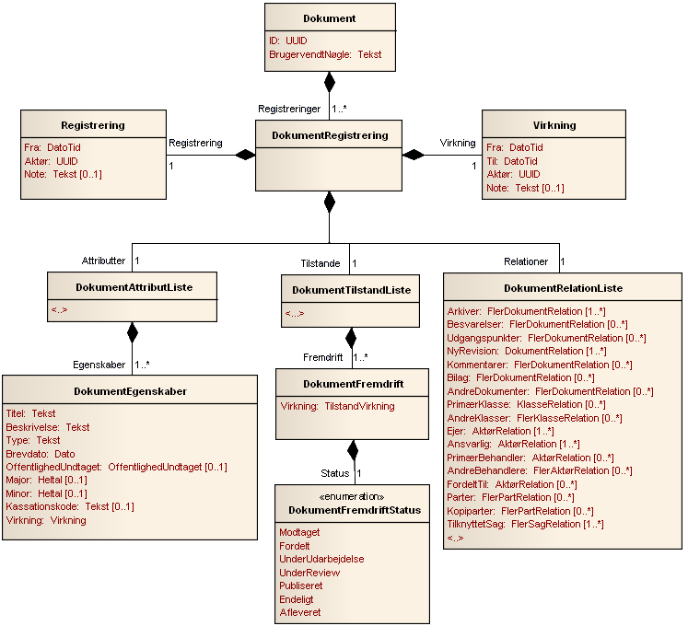
Figur 8

Timing Change - Temporal Properties
The concept of temporal characteristics comes from database world, where it provides the opportunity to represent records, which change over time in a database. We use this structure to get the opportunity to access information not only on existing relationships but also on past and future filings.

System time
The concept of system time used to define when the service's operation is called (elsewhere called transaction time). System time is represented by a timestamp:
Timestamp = 2009-10-01T23:59:59.9999

Besides the normal timing, we also need to specify logical minimum and maximum of system time:
- minimum denotes the earliest time that can be expressed in system time.
- maximum denotes the latest time that can be expressed in system time.
Intervals ]minimum, maximum[therefore means in practice ”ALLTIME”.

Registration
Every object consists of a series of records. A record corresponds to the knowledge about the object, which was available at the time of an operation call. We let the record be immutable whereby it is not subject to change.
Instead of being formed new secondary registrations for new operation calls.
This means that we consider an object as a collection of keys and values, where registration is key, and object registrations values. In computer science terms, we are dealing with a Map.

D(ID1) : Map<Registrering, Document>
= [R1->D(ID1, t1), R2-> D(ID1,t2), ... Rn->D(ID1,tn)]

UML model for registration:

Registrering
fra:Timestamp
livscyklus:LivsCyklusEnum
aktørRef: UUID

Explanation of fields:
Fra | Timestamp is automatically added to the service with the time of operation called.
Livscyklus | An Enumeration of options (Start, Imported, liabilities, Disbanded).
Aktør | A reference to the responsible actor - it can be user or user organization. The value is automatically added by the service.

Example.
The Document may stereotype realized using the following XML snippet:
<Document xmlns="urn:oio:sagdok:1.0.0" … >
<ObjectId>112</ObjectId>
<Registration>
<lifecycle>Opstået</lifecycle>
<actorID>117</actorID>
<from>-minimum</from>
</Registration>

…
</Document>

Effect
Effect allows you to specify a number of alternative versions of the same element.
Virkning
fra: TimeStamp
til:TimeStamp
aktør: Aktør
note:String

Forklaring af felterne:
Fra | Starten af Virkningsintervallet.
Til | Slutningen af Virkningsintervallet.
Aktør | En reference til den ansvarlige aktør – det kan være bruger, eller brugerens organisation. Værdien bliver automatisk tilføjet af servicen.
Note | Can be used as comment.

Business logic
- The time interval shall be consistent, "from" must be less than "to"
- If no interval is specified, the default value
] minimum , maximum[
- The time interval may be one of the following:
  - [t_0, t_1] - closed interval
  - ]minimum,t_0], [t_0, maximum[ - half open interval
  - ]minimum,maximum[=ALLTIME open interval – in practice always equal
- Actor is optional. If not specified, the default value "Organization ID".
- Frequency of an effect within the same recording might be incoherent, ie. we allow gaps.
- Closed intervals for an effect within the same ground can not overlap.
- Semi-Open and open intervals may well overlap in input. It will be of service converted to closed intervals.
Example:
UPDATE( [t1, maximum]: titel-> ”hej” ) → R1
UPDATE( [t2, maximum]: titel-> ”hej2”)-> R2
R2 = [t1,t2]: titel->”hej”, [t2,maximum]:titel->”hej2”

Explanation of stereotype <<Virkning>> - the document properties as an example
The stereotype <<virkning>> is used in UML diagrams as a notational shortcut.

Document defines a DokumentAttributModel and has annotated the relationship between DokumentAttributModel and document properties (attribute) with the stereotype <<>>. The pattern tells us that although the document at a given time have exactly one element of the document properties, we have in reality a collection of document properties.

XML fragment below shows how a document can have two impacts of the same Attribute - document properties.

The first has effect from the date 01.10.2009 title ”Hej, hej verden!!!”.
The other has the effect date 01.12.2009 title ”Hejsa”.

<Document>
<DocumentProperties>
<Validity from="2009-10-01T23:59:59.9999" to="maximum"/>
<Title>Hej, hej verden!!! </Title>
</DocumentProperties>
<DocumentProperties>
<Validity from="2009-12-01T23:59:59.9999" to="maximum"/>
<Title>Hejsa</Title>
</DocumentProperties>
</Attributes>
….....
</Document>

Example
A client calls the Document Services repeatedly.
- Create Document and records the following effects of the attribute "title":
  - From [t1, t2) is the value title = Hello
- Edit document
  - From [t2, max) is the value title = Hello
- Read the document (no time specified)
  - The returned document registration is filtered by default effects after day-date, and it corresponds to the title "Hello". A title attribute will be returned as part of the registration.
- Read the document (from = t1, maximum).
  - The returned document registration is filtered after-effect interval [t2, max) and returns 2 values for the title as part of data: Hi and Hello.

Service Operationer

Løsningsarkitektur
Med definitionen af operationer bevæger vi os væk fra Informationsmodeller og semantiske standarder ind på løsningsarkitektur. Det er ikke data – det er services, som kan gøre noget ved data, der er det centrale.
Dette afleder en række tekniske krav til
- Infrastruktur
- Sikkerhed, SignOn, Rettighedsstyring
- Service Level Agreement – for service konsumer
- Life Cycle Management – for service udbyder
- SOA Governance – for økosystemets levetid
De ovenstående tekniske krav behandles ikke i denne sammenhæng, men vil blive behandlet i den kommende vejledning om tekniske krav for dataservices, der bruger sags- og dokumentstandarder.

Input
Hver operation på hvert enkelt ServiceInterface defineres af sin egen model.
Navngivningen følger reglen: ”ServiceOperationInput”. For eksempel hedder Schema for Dokument Opret: DocumentCreateInput.xsd.
I designet af API'et har der været taget størst mulig hensyn til, at det skal være nemt at bygge klienter, som kan anvende service endepunkterne. Dette inkluderer at definere en forretningslogik, som tildeler default værdier for obligatoriske XML-elementer, så servicen kan være ”tilgivende” overfor klienten.
De fleste moderne systemer lader xml parsning foregå automatisk, i specielle klasser som er genereret ud fra Schemaet. Dette giver maksimal typesikkerhed, og udviklere behøver ikke arbejde med XML kode. Afledte skemaer kan bruge samme klasser. Skemaer med en ny struktur kræver, at der kompileres nye klasser.

XSD → Autogenererede parserklasser

For at undgå unødvendig kompleks programmering bør de enkelte Objekt specifikationer sørge for at Input strukturerne ligger i samme target namespace, og udvider samme typer som informationsmodellen.

Output
Servicen returnerer altid metadata for den sidste ObjektRegistrering, som defineret i informationsmodellen. De returnerede data indeholder alle de ændringer, som er foretaget af servicen, og vil som regel være forskellig fra input data. Undtagelsen her er søg/list, som returnerer Kollektioner, der indeholder ObjektRegistreringer.
Navngivningen følger navnet på forretningsobjektet for den pågældende service. For eksempel hedder Schema for Dokument: Document.xsd.

Fejlhåndtering
Hvis kaldet er mislykket, returneres en fejlmeddelelse. Fejlmeddelelsen indeholder en fejlkode og en meddelelse.

Transportprotokol
Man kan implementere servicen ved brug af
- REST
- WS-* stak
- Asynkron messaging
Den enkelte organisations krav til bl.a. sikkerhed er afgørende for valget.

Data Service API
Vi betragter servicen som et datalag og eksponerer derfor kun dataoperationer. Der er tale om operationerne CRUD + søg, list og passivér/importer.

Opret
Operationen Opret – CREATE er ansvarlig for at skabe et Objekt og en ObjektRegistrering og returnere ObjektRegistreringen.

CREATE(DocumentCreate.xml) -> D(UUID1,t1)

Input
Modellen for input til det enkelte Serviceinterface skal som udgangspunkt være tilgivende, og tillade at bruge så lidt information som muligt for at oprette et Objekt. Hvis der findes obligatoriske elementer, er det et designvalg, om forretningslogikken skal sørge for at definere default værdier for disse.

OpretInput
virkning:Virkning
attributter [0..n]:Attribut
relationer [0..n]:Relation
tilstande [0..n]:Tilstand

Elementforklaring:
Element | Obligatorisk | Default værdi tildelt af systemet
Virkning | Nej | ]minimum, maximum[
Attributter | Nej/Ja | Defineret af forretningslogik
Relationer | Nej/Ja | Defineret af forretningslogik
Tilstande | Nej/Ja | Defineret af forretningslogik

For eksempel kan et tomt Dokument Objekt oprettes ved at kalde Opret operationen i DokumentService med følgende xml-fragment:

<oio:Document xmlns:oio="urn:oio:sagdok:1.0.0" xmlns:xsi="http://www.w3.org/2001/XMLSchema-instance" xsi:schemaLocation="urn:oio:sagdok:1.0.0 DokumentCreateInput.xsd " />

Output
Returværdien er en ObjektRegistrering, som indeholder den nye UUID, svarende til returværdien fra et kald til READ(UUID1).

Forretningslogik
Servicen opretter et nyt Objekt, og tildeler den en unik, global UUID.
Livscyklus tilstanden sættes til ”OPSTÅET”.
Servicen skaber en ObjektRegistrering, og ”befolker” datastrukturen, som angivet af Input strukturen.

Læs
Operationen Læs – READ – har ansvar for at returnere den sidste ObjektRegistrering.

Input
Som input angives objektID samt et optionelt virkningsinterval.

Parametre:
Element | Obligatorisk | Default værdi tildelt af systemet
objektID | JA | Fejl!
virkningsInterval | Nej | NU

Output
Output er Objektstruktur som defineret af Informationsmodellen, og det tilsvarende Schema. F.eks. returneres fra DokumentService et xml dokument, genereret på Document.xsd schema.

Forretningslogik
- Returnerer altid sidste ObjektRegistrering
- Alle objekter kan læses – også de udstemplede.
- En angivelse af virkningsinterval filtreres igennem ObjektRegistreringen.
- Kaldet fejler, hvis objektID ikke findes.

Opdatér
Operationen Opdater - UPDATE – har ansvar for at skabe en ny ObjektRegistrering, og indføre de ændringer, som er angivet i Input strukturen.

UPDATE(DocumentUpdate.xml) → D(UUID1,t1)

Input
Som udgangspunkt ville vi gerne nøjes med kun at have ændringerne som input parameter. Det er dog lidt kompliceret med kollektioner, idet der skal kunne slettes et kollektionselement.

Element | Obligatorisk | Default værdi tildelt af systemet
objektID | JA | Fejl!
Attributter | NEJ | Forhenværende registrerings data videreføres
Tilstande | NEJ | Forhenværende registrerings data videreføres
Relationer | NEJ | Forhenværende registrerings data videreføres

Output
Den nye registrering, svarende til returværdien for READ.

Forretningslogik
- Når et objekt rettes, dannes en klon af de elementer, der ændres og der kan tilføjes elementer, der ikke fandtes i forvejen.
- Hvert af de oprindelige elementer, der bliver ændret, får registreretTil=ts(), mens de nye elementer får registreretFra=ts(). Det nye element får de nye værdier.
- Hvis man forsøger at rette i et udstemplet objekt eller et udstemplet element, vil det være som at oprette det på ny – dvs. der dannes ingen klon.
- Hvis UUID mangler eller ikke kan matches af et eksisterende objekt, fejler kaldet.
- Hvis et element i en kollektion mangler, svarer det til sletning.

Slet
Slet har ansvar for at skabe en ny registrering, med Livscyklus tilstanden sat til ”NEDLAGT”.
Delete(uuid1) → D(UUID1,t1)

Input
Et objektID.

Output
Den nye registrering bliver returneret, svarende til READ operationen.

Forretningslogik
- Et objekt med den angivne uuid skal være defineret, og må ikke have tilstanden ”NEDLAGT”.
- Livscyklus variablen bliver ændret til ”NEDLAGT”.

Import
Import har ansvar for at skabe et nyt Objekt og en ny ObjektRegistrering i servicen, baseret på data hentet fra en anden service (den oprindelige service).

IMPORT(DocumentImport.xml) → D(UUID1,t1)

Input
Et komplet Objekt, som inkluderer objektID, svarende til returværdien fra READ i den oprindelige service.

Output
Servicen returnerer den nye registrering, svarende til et kald for READ.

Forretningslogik
- Et nyt Objekt og en ny ObjektRegistering bliver skabt – men servicen genererer ikke en ny UUID.
- UUID skal være sat i Inputstrukturen
- Livscyklus bliver sat til ”Importeret”.
- Når et importeret objekt læses, skal det fremgå af StdRetur, at ’registreringer før importeret’ ikke har fundet sted i denne service.

Passiv
Passiv har ansvar for at markere, at Servicen ikke er ansvarlig for at vedligeholde et Objekt. Specielt behøver den ikke abonnere på hændelser.
Passiv(UUID1) → D(UUID1,t1)

Input
Et objektID.

Output
Servicen returnerer den nye registrering, svarende til et kald for READ.

Forretningslogik
- Når et objekt passiveres, er det alene livscyklustilstanden ’passiv’, der bliver sat med registreretFra = ts()
- Passiv betyder, at vedligeholdelse af objektet ikke finder sted i den pågældende service.
- Når et passiveret objekt læses, skal det fremgå af StdRetur at ’registreringer efter passiveret’ ikke finder sted i denne service.

List
List bruges til at arbejde med tidsperspektivet, og kan derfor filtrere på Registreringsinterval og Virkningsinterval.
LIST([UUID1,..UUIDn], ValidPeriod, RegistrationPeriod) → [D(UUID1,t1), D(UUID1,t2) ... D(UUID2,t3),... ]

Input
- Liste af ObjektId - obligatorisk
- Virkningsperiode - optionel
- Registreringsperiode – optionel.

Output
En liste af objektregistreringer filtreret igennem virkning og registrering.

Forretningslogik
- List kan returnere forhenværende ObjektRegistreringer

Søg
Baseret på søgekriterie – fx ”ligesom mig” - returnerer SEARCH en liste af relevante ObjektRegistreringer. Det er muligt at angive et Registreringsinterval. Hvis dette udelades, foregår søgningen kun på de seneste registreringer.

SEARCH(SearchInput.xml, ValidPeriod, RegistrationPeriod) → [D(UUID1,t1), D(UUID1,t2) ... D(UUID2,t3),... ]

Input
En ”tilgivende” Dokument.xsd variant, som gør det muligt at udelade ting, eller have for mange med, fx en liste af objektId'er, eller en ”regular expression” i stedet for titel.

Output
En liste af registreringer som modsvarer søgekriterierne.

Forretningslogik
- Som minimum skal søgning kunne returnere objektregistreringer svarende til objektId.
- Forskellige søgningsstrategier er tilladte.
- Der bruges paginering for at begrænse returmængdens størrelse.

Hændelser

Baggrund
Referencearkitekturen for Sag og Dokument definerer begreberne Hændelse, Specifik Hændelse og HændelsesFordeler, som skal binde den service orienterede arkitektur sammen.
Med baggrund i ’Anbefaling for en generel hændelsesbesked version 1.0’ indeholder dette dokument et forslag til en specifik hændelsesbesked, som kan håndteres af den generelle hændelsesbesked.
”Teknisk Vejledning for Sag og Dokument” (nærværende dokument?), behandler infrastrukturen og de ikke funktionelle krav.
Dette dokument er en semantisk gennemgang af hændelse.

Hvad er en hændelse?
Der udstedes en hændelse for et objekt når dets data bliver ændret, det vil sige, når der bliver skabt en ny registrering.
Sag og Dokument definerer en Specifik Hændelse, som er en minimal notifikationsstruktur. Denne bliver indlejret i “Extenstion (Extension?) Structure” fra standarden for Generel Hændelse. Generel Hændelse er som en ydre konvolut, og hændelse er som indholdet.

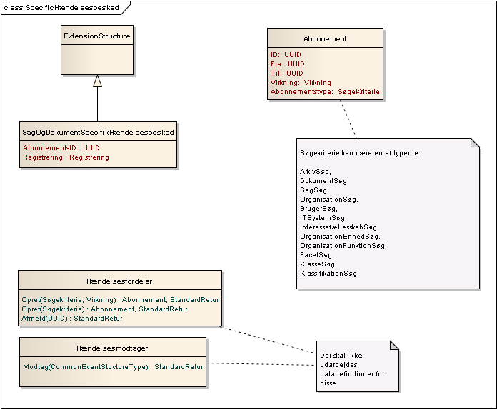
Figur 9

Operation API for Hændelser
Da vi ikke vil stille krav om infrastruktur, opererer vi med en minimalistisk hændelsesmodel, og en push-notify arkitektur. Denne løsning kan både tilbydes i et avanceret enterprise miljø, men også i et miljø med masser af legacy - det er nok at have et URI.

Hændelsesfordeler
Hændelsesfordeler, som har operationerne Opret og Afmeld.
Ved Opret angives et søgekriterie, som repræsenterer de ressourcer, som man er interesseret i at modtage hændelser for.

Hændelsesfordeler
Opret(AbonnementInputMeddelse): Abonnement
Afmeld(abonnementsID:UUID): StandartRetur
Tabel 1

HændelsesModtager
Dette er en call-back URI, altså et interface man skal have, for at kunne modtage en hændelse.

HændelsesModtager
Modtag(GenerelHændelse):StandartRetur
Tabel 2

Referencer
Notation | Reference
[Fowler] | Martin Fowler, Temporal Pattern. http://martinfowler.com/ap2/temporalProperty.html
[UML] | Martin Fowler, UML distilled.
[Etutorials] | Etutorials.org http://etutorials.org/Programming/UML/Chapter+6.+Class+Diagrams+Advanced+Concepts/Parameterized+Class/

Dette afhænger af det enkelte ForretningsObjekt. Som udgangspunkt skal det være obligatorisk at have de elementer med, som er obligatoriske i informationsmodellen, men som ikke kan tildeles en fornuftig default værdi.

